FACULTY EVALUATION
Programme Name: SBVP ALUMNI MASTERCLASS - SCALE Module I Online Zambia (20th April 2026 - 24th April 2026)
Session: Reflect on Vision and Mission
Faculty Name: Lena Gachoki
No. of Respondents: 13
No. of Participants: 13
Evaluation Parameter | (%) Individual Score | (%) Programme Average
Punctuality (Commencement and Completion of Sessions) | 100 | 75
How well do you understand the core concepts presented? | 89 | 72
Rate your confidence in applying the new skills learnt | 88 | 72
Degree of Faculty preparedness for the sessions | 94 | 76
Content and methodology of the program | 95 | 77
Quality of class and group discussions | 91 | 72
The information presented in the course is relevant to my work (ministry) | 97 | 76
Average scores | 93 | 74

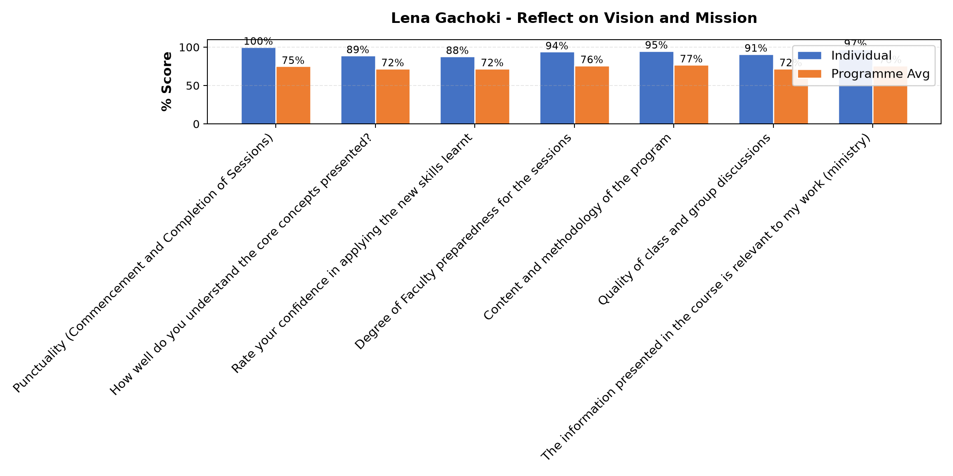

Comments & Feedback
- • Session was perfect
- • It was great
- • Change of perception especially on those I find difficult to work wolith
- • Lack of confident.
- • No barriers will prevent me from applying this rich information learnt today
- • Assertiveness
- • Understanding myself well enough
- • Great lesson
SUBMITTED THROUGH:
SBS Evaluation Automation System

